Git Hands-on Lab 4

Objective
Implement conflict resolution when multiple users modify the same file in different branches, resolve the merge conflict, update .gitignore, and verify the repository history.

Prerequisites
- Git for Windows
- Git Bash
- Notepad++ configured as Git editor
- Existing GitDemo repository
- Completed Git HOL 3

Procedure
Step 1: Verify master is clean
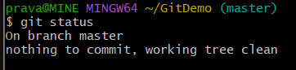
Step 2: Create branch
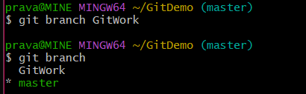
Step 3: Switch to branch
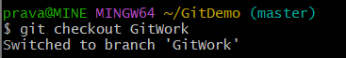
Step 4: Create hello.xml
Step 5: Verify file
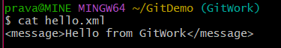
Step 6: Check status
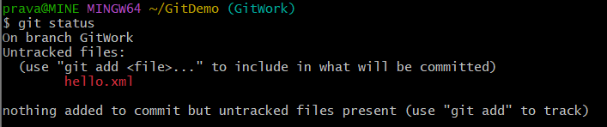
Step 7: Commit branch changes
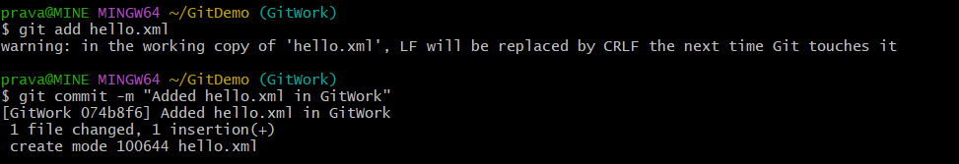
Step 8: Switch to master
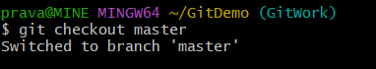
Step 9: Create different hello.xml
Step 10: Commit master changes
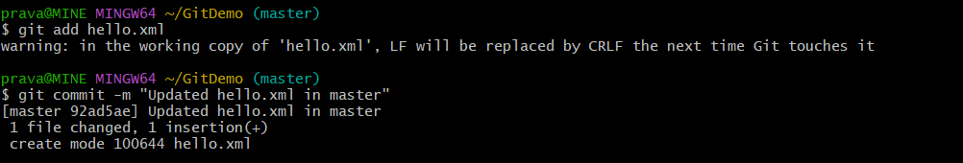
Step 11: View commit graph
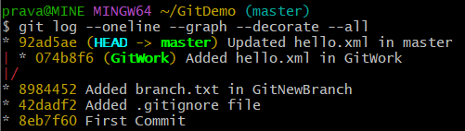
Step 12: Compare branches
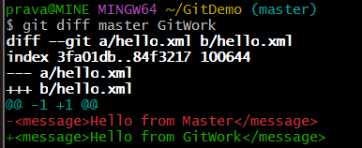
Step 13: Merge branch
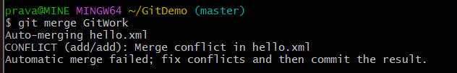
Step 14: Resolve conflict
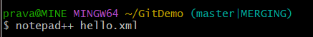
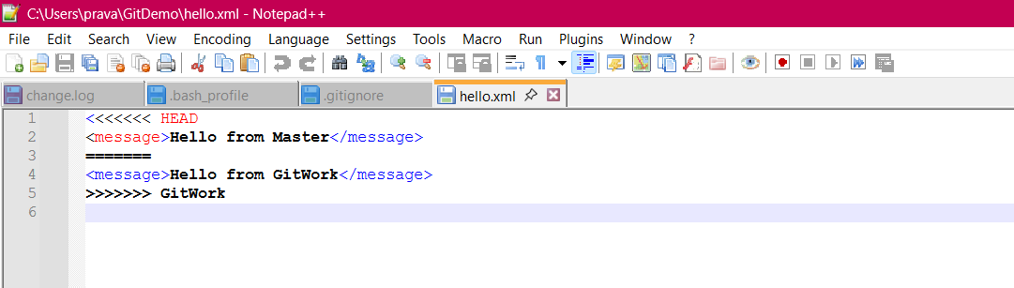
- hello.xml is edited to remove conflict markers.
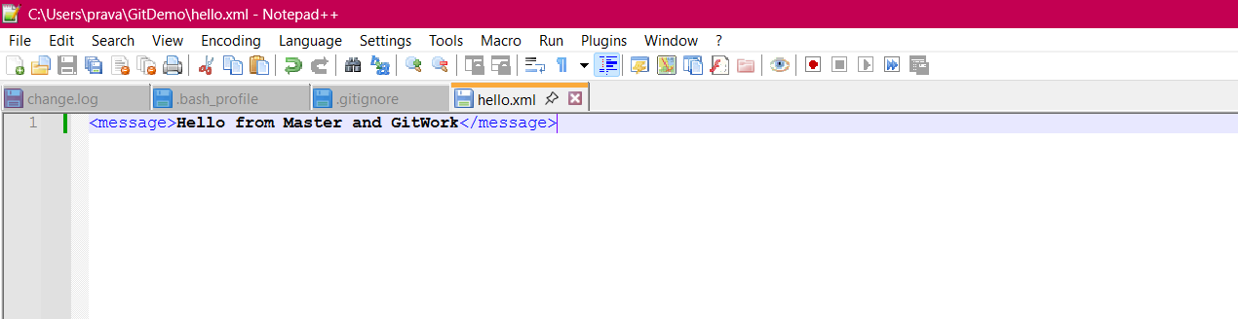
Step 15: Complete merge
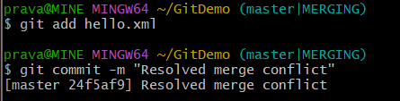
Step 16: Verify repository
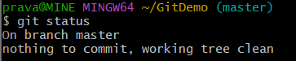
Step 17: Update .gitignore
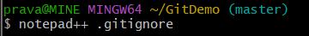
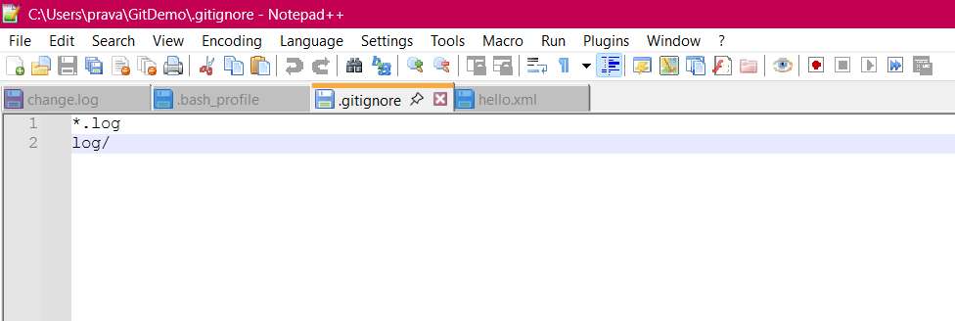
Add: *.orig
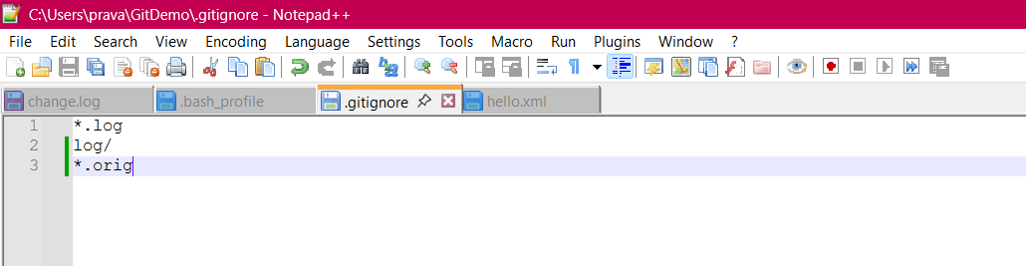
Step 18: Commit .gitignore
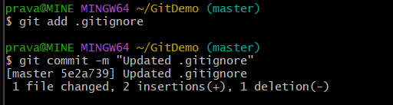
Step 19: List branches

Step 20: Delete merged branch
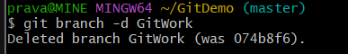
Step 21: View final log
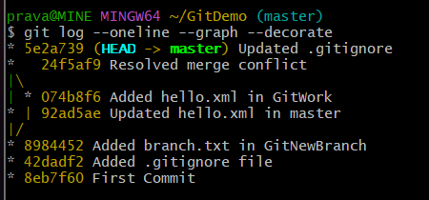

Result
The merge conflict was resolved successfully. The merged changes were committed to the master branch, .gitignore was updated, the GitWork branch was deleted, and the repository history was verified.

Conclusion
Git branching, merging, conflict resolution, and repository maintenance were performed successfully.

